Il ne faut pas oublier d’installer la librairie permettant de communiquer avec la NodeMCU

Firstly open the Arduino IDE

Go to files and click on the preference in the Arduino IDE

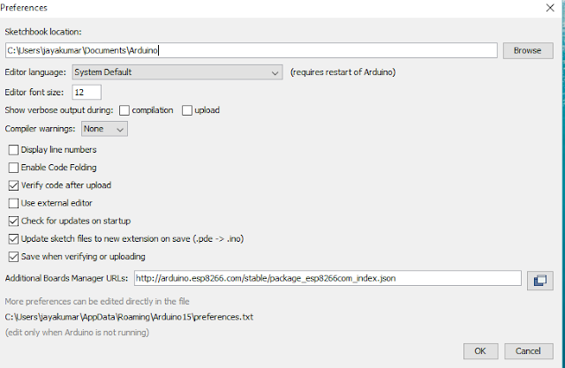

copy the below code in the Additional boards Manager

http://arduino.esp8266.com/stable/package_esp8266com_index.json

click OK to close the preference Tab.

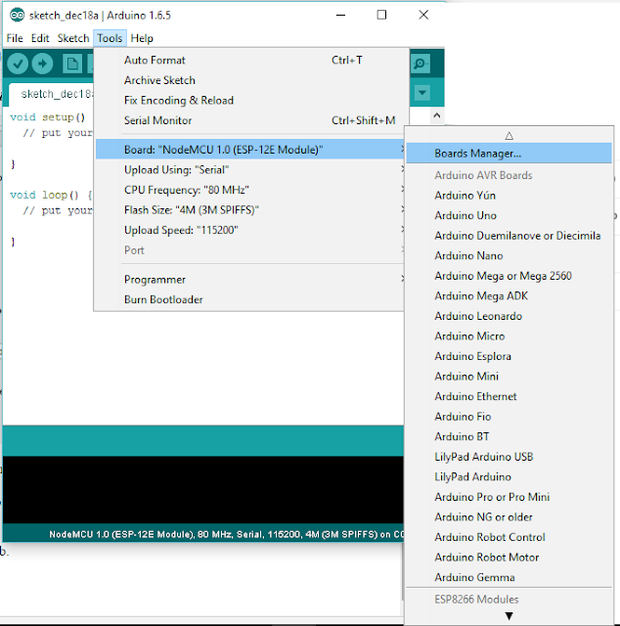

After completing the above steps , go to Tools and board, and then select board Manager

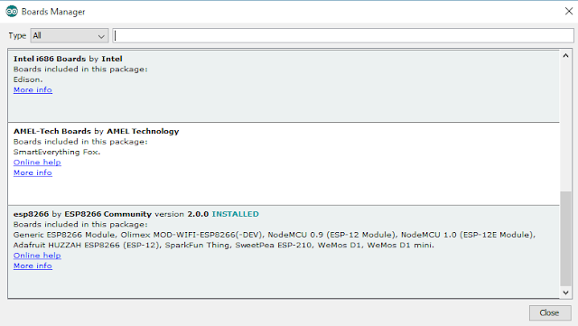

Navigate to esp8266 by esp8266 community and install the software for Arduino.

Once all the above process been completed we are read to program our esp8266 with Arduino IDE.

Lien : https://www.instructables.com/id/Quick-Start-to-Nodemcu-ESP8266-on-Arduino-IDE/